***CHENNAI INSTITUTE OF TECHNOLOGY***

Sarathy Nagar, Kundrathur, Chennai-600069

*An Autonomous Institute Approved by AICTE and Affiliated to Anna University, Chennai*

**ELECTRICAL AND ELECTRONICS ENGINEERING**

**(Smart Oil Flow Monitoring & Analysis)-An IoT-Driven Solution with Real-Time Insights**



A Report on Core Course Project

ELECTRICAL AND ELECTRONICS ENGINEERING

By

GOKUL NAATH M (23EE011)

ALFRED JOHN S (23EE002)

**April / May - 2025**

**CHENNAI INSTITUTE OF TECHNOLOGY**

**CHENNAI-69**



**Vision of the Institute:**

To be an eminent centre for Academia, Industry and Research by imparting knowledge, relevant practices and inculcating human values to address global challenges through novelty and sustainability.

**Mission of the Institute:**

**IM1**.To creates next generation leaders by effective teaching learning methodologies and instill scientific spark in them to meet the global challenges.

**IM2**.To transform lives through deployment of emerging technology, novelty and sustainability.

**IM3**.To inculcate human values and ethical principles to cater the societal needs.

**IM4**.To contributes towards the research ecosystem by providing a suitable, effective platform for interaction between industry, academia and R & D establishments.

**IM5**.To nurture incubation centres enabling structured entrepreneurship and start-ups.

**Department of Electrical and Electronics Engineering**

**Vision of the Department**:

To Excel in the emerging areas of Electrical and Electronics Engineering by imparting knowledge, relevant practices and inculcating human values to transform the students as potential resources to meet the industrial and societal needs.

**Mission of the Department**:

**DM1**: To provide strong fundamentals and technical skills through effective teaching learning Methodologies

**DM2**: To transform lives of the students by fostering ethical values, creativity and novelty to become entrepreneurs and establish start-ups.

**DM3**: To habituate the students to focus on sustainable resources with optimal usage to ensure the welfare of the society.

**DM4**: To provide an ambience for research through collaborations with industry and academia

**DM5**: To inculcate learning of emerging technologies for pursuing higher studies

Leading to life long learning.

**CHENNAI INSTITUTE OF TECHNOLOGY**

*An Autonomous Institute*

**CHENNAI-69**



**CERTIFICATE**

This is to certify that the “**Core Course Project**” Submitted by **Gokul Naath M, Alfred John S (Reg no: 23EE011, 23EE002)** is a work done by them and submitted during **2025-2026** academic year, in partial fulfilment of the requirements for the award of the degree of **BACHELOR OF ENGINEERING** in **DEPARTMENT OF ELECTRICAL and ELECTRONICS ENGINEERING**

|  |  |
| --- | --- |
| **Core Course**  **Project Coordinator** | **Head of Department** |
| **Internal Examiner** | **External Examiner** |

**ACKNOWLEDGEMENT**

We express our gratitude to our Chairman **Shri.P.SRIRAM** and all trust members of Chennai institute of technology for providing the facility and opportunity to do this project as a part of our undergraduate course.

We are grateful to our Principal **Dr.A.RAMESH M.E**, **Ph.D.** for providing us the facility and encouragement during the course of our work.

We sincerely thank our Head of the Department, Dr.SHANKAR, Department of Electrical and Electronics Engineering for having provided us valuable guidance, resources and timely suggestions throughout our work.

We would like to extend our thanks to our **faculty coordinator, Mr.ELIL MARAN of the Department of Electrical and Electronics Engineering**, for their valuable suggestions throughout this project.

We wish to extend our sincere thanks to all **Faculty members of the Department of Electrical and Electronics Engineering** for their valuable suggestions and their kind cooperation for the successful completion of our project.

We wish to acknowledge the help received from the **Lab Instructors of the Electrical and Electronics Engineering** and others for providing valuable suggestions and for the successful completion of the project.

**ALFRED JOHN S (23EE002)**

**GOKUL NAATH M(23EE011)**

**PREFACE**

I, a student in the Department of Electrical and Electronics Engineering need to undertake a project to expand our knowledge. The main goal of our core project is to acquaint us with the practical application of the theoretical concepts I’ve learned during my course.

It was a valuable opportunity to closely compare theoretical concepts with real-world applications. This report may depict deficiencies on my part but still it is an account of our effort.

The results of our analysis are presented in the form of an industrial Project, and the report provides a detailed account of the sequence of these findings. This report is my Core Course Project, developed as part of our 2nd project. As an engineer, it is our responsibility to contribute to society by applying my knowledge to create innovative solutions that address their changes.

**ABSTRACT**

**(Smart Oil Flow Monitoring & Analysis: An IoT-Driven Solution with Real-Time Insights)**

**This project introduces an IoT-based smart oil flow monitoring system that enables real-time data acquisition, cloud storage, and analytics. An ESP32 microcontroller measures oil levels and flow rates using ultrasonic and flow sensors. The collected data is sent to Google Sheets via an HTTP request, ensuring cloud-based storage and easy remote access. A custom mobile application retrieves data from Google Sheets and visualizes it through pie charts and graphs for intuitive flow rate analysis.**

**Additionally, the system features automated motor control, turning the motor on/off based on predefined oil level conditions. The integration of Google Sheets and app analytics enables efficient monitoring, predictive analysis, and automation. This solution enhances operational efficiency, reduces manual intervention, and improves decision-making for industries dealing with oil flow management. Its real-time insights make it highly useful for commercial and industrial applications, providing a cost-effective and scalable monitoring system.**

|  |  |  |
| --- | --- | --- |
|  | Content |  |
| Chapter No | Title | Page No. |
| **1** | **Introduction** | **9** |
| **2** | **Project Requirements** | **11** |
| **3** | **Project Objective** | **12** |
| **4** | **PROJECT REQUIREMENTS** | **15** |
| **5** | **MECHANISM** | **18** |
| **6** | **CONCLUSION** | **30** |

**INTRODUCTION**

**((Smart Oil Flow Monitoring & Analysis: An IoT-Driven Solution with Real-Time Insights)**

In industries and commercial sectors, monitoring the flow and consumption of oil is crucial for efficient resource management, cost reduction, and operational safety. Traditional methods of oil flow measurement often involve manual inspections, which are prone to human error and inefficiency. With advancements in IoT (Internet of Things) and cloud computing, real-time monitoring and automated control systems have become viable solutions for enhancing accuracy, reliability, and ease of access to critical data.

This project presents an **IoT-based Oil Flow Monitoring System** that integrates **ESP32 microcontroller technology, Google Sheets for cloud data logging, and a mobile application for visualization**. The system employs **ultrasonic sensors to measure oil levels and flow sensors to monitor real-time flow rates**. Data collected from the sensors is transmitted to Google Sheets via HTTP requests, where it is stored and analyzed. A dedicated mobile application retrieves this data from the cloud and presents it through **interactive dashboards, pie charts, and graphs**, enabling users to gain real-time insights into oil consumption trends.

The system is designed to provide a **cost-effective, scalable, and user-friendly** approach to oil flow monitoring. **When the oil level reaches a critical threshold, the system automatically controls the motor**—turning it on or off as needed to maintain optimal levels. **The integration with Google Sheets ensures that data is stored securely and accessible from anywhere**, eliminating the need for on-site monitoring. Moreover, the mobile application provides real-time analysis, alert notifications, and trend forecasting, making it a powerful tool for decision-making.

**Project Objective**

**(TrackWind – Harnessing Train-Induced Wind for Renewable Energy)**

**1. Real-Time Monitoring of Oil Flow and Levels**

One of the primary objectives of this project is to enable real-time monitoring of oil flow and levels in storage tanks or pipelines. By utilizing ultrasonic sensors for level measurement and flow sensors for tracking oil movement, the system ensures accurate and continuous data acquisition. This eliminates the need for manual inspections and provides precise, up-to-the-minute readings.

**2. Integration of IoT for Automated Data Logging**

The system leverages IoT technology to send real-time sensor readings to a cloud-based storage system using Google Sheets. This approach allows for secure and structured data storage, making historical trends easily accessible for analysis. By integrating with the cloud, stakeholders can access vital oil flow data remotely, enhancing operational efficiency.

**3. Automated Motor Control Based on Oil Levels**

To optimize resource utilization and prevent overflow or depletion, the system incorporates a relay-controlled motor that automatically turns ON or OFF based on predefined oil levels. If the oil level reaches 100%, the motor is switched OFF to prevent overflow, while if the level drops below a critical threshold, the motor is activated to maintain a steady supply.

**4. Development of a Mobile Application for Visualization**

A key aspect of this project is the creation of a user-friendly mobile application that retrieves data from Google Sheets and presents it through interactive dashboards, pie charts, and trend graphs. This feature allows users to monitor oil consumption patterns visually, facilitating better decision-making and predictive maintenance.

**5. Enhancing System Efficiency and Reliability**

The project aims to eliminate human errors associated with manual oil monitoring by ensuring accurate and reliable sensor readings. With automated updates and notifications, the system alerts users to critical conditions, preventing mishaps such as unexpected shortages or overflows.

**6. Implementation of Alert and Notification System**

The system is designed to send instant alerts via Telegram or mobile notifications when oil levels reach predefined thresholds. This ensures timely actions, reducing risks associated with oil mismanagement in industries.

**7. Cost-Effective and Scalable Solution**

The proposed system is built using affordable and scalable components such as the ESP32 microcontroller and widely available sensors. Its modular nature allows easy expansion, making it suitable for a variety of industrial applications, from small-scale setups to large refineries.

**8. Secure Data Handling and Accessibility**

With the integration of Google Sheets, the system ensures secure, structured, and easily retrievable data storage. Users can view, analyze, and share reports effortlessly from any location, making remote monitoring feasible and effective.

**9. Environmental and Energy Efficiency Considerations**

The project is designed to minimize energy consumption by optimizing motor operations and reducing wastage. Additionally, by monitoring oil usage patterns, industries can take proactive steps toward sustainable resource management, aligning with global energy efficiency initiatives.

**10. Future Scope and Scalability**

The system is developed with future enhancements in mind. Potential upgrades include AI-driven predictive analytics, LoRa/GSM-based long-range communication, and blockchain integration for secure data management. These enhancements will further improve the accuracy, reliability, and reach of the monitoring system.

By addressing these objectives, the project not only enhances oil flow monitoring but also contributes to overall industrial efficiency, cost savings, and operational safety.

**PROJECT REQUIREMENTS**

**These components include:**

**1.1 ESP32 Microcontroller**

**1.2 Ultrasonic Sensor (HC-SR04)**

**1.3 Flow Sensor (YF-S201 or Similar)**

**1.4 Relay Module (JQC3F-05VDC-C)**

**1.5 AC Motor**

**1.6 Power Supply (5V/12V Adapter)**

**1.7 OLED Display (Optional)**

**Hardware Components**

* 1. **ESP32 Microcontroller**

**Description:** The ESP32 is a low-power microcontroller with built-in Wi-Fi and Bluetooth capabilities.

**Usage:** Serves as the central processing unit for data collection, processing, and transmission.

**How It Works:** Reads sensor data, processes it, and sends it to Google Sheets via Wi-Fi.

**Role in Project:** Controls sensors and relays, manages data, and enables IoT connectivity.

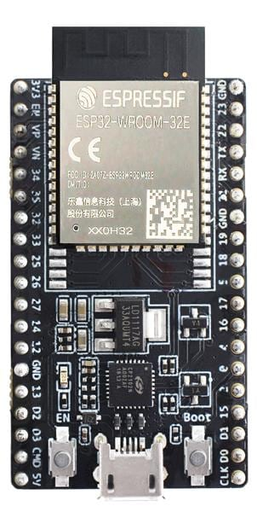

**1.2 Ultrasonic Sensor (HC-SR04)**

**Description:** A sensor that uses ultrasonic waves to measure distances.

**Usage:** Measures oil level inside the tank.

**How It Works:** Sends sound waves, measures the time taken for the echo to return, and calculates distance.

**Role in Project:** Helps monitor the oil level to prevent overflows or shortages.

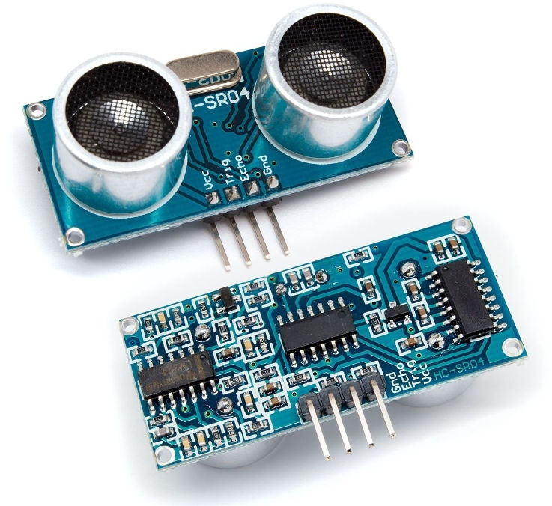

**1.3 Flow Sensor (YF-S201 or Similar)**

**Description:** A turbine-based sensor that measures the flow rate of liquid.

**Usage:** Measures the amount of oil flowing through the pipeline.

**How It Works:** Generates electrical pulses proportional to the flow rate.

**Role in Project:** Helps determine oil consumption and detect irregularities.

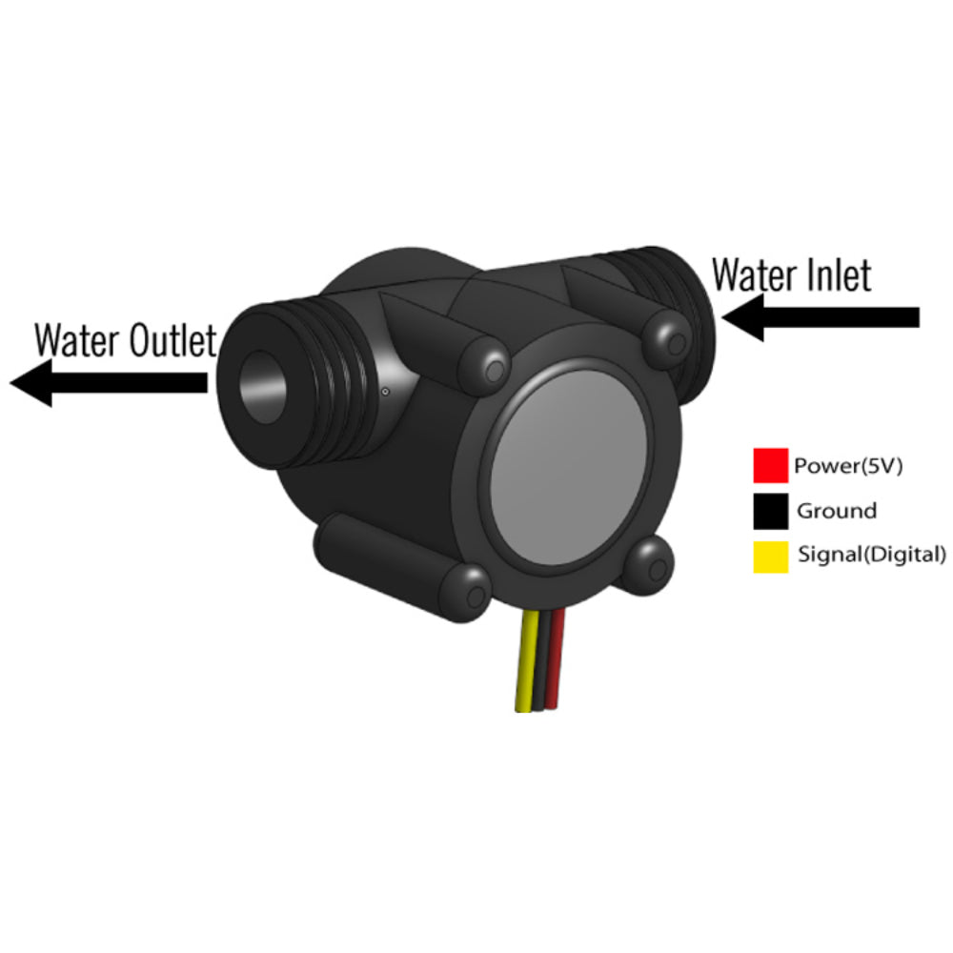

**1.4 Relay Module (JQC3F-05VDC-C)**

**Description:** A switch that can be controlled electronically to turn high-power devices on or off.

**Usage:** Controls the AC motor used for pumping oil.

**How It Works:** Uses a small signal from the ESP32 to activate a high-power circuit.

**Role in Project:** Turns the motor ON/OFF based on oil level.

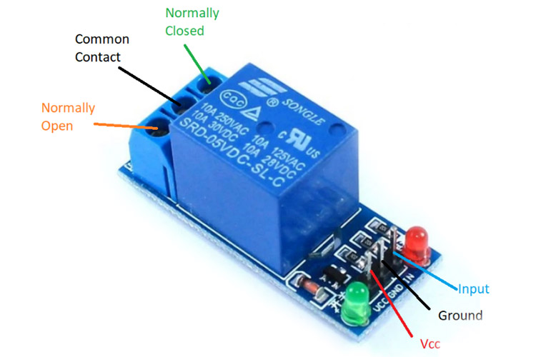

**1.5 AC Motor**

**Description:** An electric motor powered by alternating current.

**Usage:** Pumps oil when required.

**How It Works:** Converts electrical energy into mechanical motion to drive oil flow.

**Role in Project:** Ensures oil is pumped only when necessary.

**1.6 Power Supply (5V/12V Adapter)**

**Description:** Provides stable power to the ESP32, sensors, and relay.

**Usage:** Supplies necessary voltage and current to the components.

**How It Works:** Converts AC mains power to regulated DC power.

**Role in Project:** Ensures uninterrupted operation of the system.

**1.7 OLED Display (Optional)**

**Description:** A compact display module used for real-time data visualization.

**Usage:** Shows oil level, flow rate, and motor status.

**How It Works:** Receives data from the ESP32 and displays it.

**Role in Project:** Provides immediate feedback without requiring a mobile device.

**Key Features:**

**Key Features:**

1. **Real-Time Oil Flow Monitoring** – Tracks oil flow rate and total volume in real time.
2. **Oil Level Detection** – Monitors oil level using an ultrasonic sensor.
3. **Automated Motor Control** – Turns motor ON/OFF based on oil level.
4. **Google Sheets Integration** – Stores flow rate, oil level, and motor status in a Google Sheet for analysis.
5. **Mobile App Visualization** – Displays real-time data using charts and analytics.
6. **Remote Monitoring via Telegram** – Sends alerts when the tank is full or empty.
7. **Power Efficiency** – Optimized energy consumption for continuous operation.
8. **Fail-Safe Mechanism** – Ensures reliable operation in case of sensor failure.

**Components & Descriptions**

**1. ESP32 (Microcontroller)**

* **Description:** A low-power microcontroller with built-in Wi-Fi and Bluetooth.
* **Usage:** Controls sensors, processes data, and sends information to Google Sheets and Telegram.
* **Function in Project:** Collects and transmits sensor data, executes automation logic.

**2. Ultrasonic Sensor (HC-SR04)**

* **Description:** Measures distance using ultrasonic sound waves.
* **Usage:** Detects oil level in the tank.
* **Function in Project:** Calculates oil level percentage and determines motor control actions.

**3. Flow Sensor (YF-S201 or similar)**

* **Description:** Measures the flow rate of liquid passing through it.
* **Usage:** Tracks the amount of oil flowing in liters per minute.
* **Function in Project:** Sends pulse signals to ESP32, which calculates flow rate.

**4. Relay Module (JQC3F-05VDC-C)**

* **Description:** Electrically operated switch for controlling high-power devices.
* **Usage:** Turns AC motor ON or OFF based on oil level.
* **Function in Project:** Prevents overflow and ensures consistent oil supply.

**5. AC Motor**

* **Description:** A high-power motor for pumping oil.
* **Usage:** Transfers oil when needed.
* **Function in Project:** Operates when oil level is low and stops when the tank is full.

**6. Wi-Fi Module (Built into ESP32)**

* **Description:** Enables wireless data transmission.
* **Usage:** Sends data to Google Sheets and mobile app.
* **Function in Project:** Provides cloud-based monitoring and remote access.

**7. Google Sheets API**

* **Description:** Cloud-based data storage and visualization tool.
* **Usage:** Stores oil level, flow rate, and motor status.
* **Function in Project:** Allows for historical analysis and real-time tracking.

**8. Mobile App (Using MIT App Inventor or Flutter)**

* **Description:** Displays real-time analytics through charts and graphs.
* **Usage:** Visualizes oil flow rate and motor status.
* **Function in Project:** Provides a user-friendly interface for monitoring system data.

**9. Telegram Bot**

* **Description:** Sends real-time alerts and updates.
* **Usage:** Notifies users of critical system updates (e.g., tank full, low oil level).
* **Function in Project:** Ensures remote monitoring and quick response to critical conditions.

**10. Power Supply (5V DC for ESP32, 230V AC for Motor)**

* **Description:** Provides power to the system.
* **Usage:** Ensures reliable operation of sensors and motor.
* **Function in Project:** Maintains continuous functionality with minimal interruptions.

**Additional Components (Optional)**

* **LCD/OLED Display:** Displays real-time data on-site.
* **Buzzer:** Provides audible alerts for critical conditions.
* **Battery Backup:** Ensures functionality during power outages.
* **LoRa Module:** Alternative for long-range wireless communication.

These components collectively ensure that the system operates efficiently, providing accurate monitoring and automation for oil flow and level control.

**Efficiency and Safety Features**

* **Automated Monitoring & Data Logging**: The system continuously tracks oil flow rate and tank levels, updating data in real time to Google Sheets and the mobile app.
* **Automatic Motor Control**: The relay module ensures the motor operates only when necessary, shutting off when the tank reaches 100% to prevent overflow.
* **Error Detection & Alerts**: The system detects anomalies in flow rate, oil levels, or motor performance and sends alerts through Telegram or the mobile app.
* **Remote Accessibility**: Users can monitor system status from anywhere using Google Sheets integration and the app, improving decision-making efficiency.
* **Power Efficiency**: Optimized power management ensures the ESP32 and sensors consume minimal energy while maintaining accurate monitoring.
* **Circuit Protection**: The relay module and appropriate fuses protect against electrical faults, preventing short circuits and motor damage.
* **Environmental Safety Compliance**: The system ensures safe oil handling by avoiding spills and maintaining proper flow control, reducing potential hazards.
* **Emergency Override**: A manual override switch allows the motor to be shut off in case of system failure, ensuring operational safety.
* **Data Backup & Recovery**: Logs stored in Google Sheets ensure historical records remain intact for audits and analysis, even in case of ESP32 failure.
* **User-Friendly Interface**: The mobile app provides intuitive charts and analysis tools, allowing users to make informed decisions on system operation.

**MECHANISM**

**Mechanism of the Project:**

The oil monitoring system operates using a combination of sensors, microcontrollers, communication modules, and an automated motor control mechanism. Below is the step-by-step process of how the system functions:

1. **Oil Flow Measurement:**
   * The flow sensor detects the amount of oil passing through the system by measuring the pulses generated as the liquid flows. These pulses are counted and converted into a flow rate (liters per minute).
2. **Oil Level Detection:**
   * The ultrasonic sensor continuously measures the distance between the oil surface and the top of the tank. The oil level is calculated based on the tank depth and mapped to a percentage value.
3. **Motor Control Mechanism:**
   * The relay module acts as a switch to control the AC motor.
   * If the oil level reaches 100%, the motor is automatically turned off to prevent overflow.
   * If the oil level drops to 0%, the motor is turned on to initiate the refilling process.
4. **Data Processing & Communication:**
   * The ESP32 microcontroller processes real-time data from the sensors and determines appropriate actions.
   * It sends the measured flow rate, oil level, and motor status to a cloud-based Google Sheets database using Wi-Fi connectivity.
5. **Remote Monitoring & Alerts:**
   * The system updates the Google Sheets dashboard in real time, allowing remote users to access and analyze the data.
   * A Telegram bot sends instant alerts if the oil level reaches critical thresholds or if any system malfunction is detected.
   * The mobile application retrieves the data from Google Sheets and presents it using graphical analysis such as pie charts for better visualization
6. **Power Management & Safety Features:**
   * The system optimizes power consumption by controlling the operation of sensors and the microcontroller efficiently.
   * Safety mechanisms, including circuit protection and emergency override switches, ensure that the system remains operational under all conditions.
7. **User Interaction & Decision Making:**
   * The user can manually override the system to stop or start the motor if needed.
   * Historical data analysis helps users in predictive maintenance and operational efficiency improvements.

By integrating these mechanisms, the system provides a seamless, automated, and efficient oil monitoring solution while ensuring safety and real-time accessibility.

**METHODOLOGY**

**Summary of the Working Mechanism:**

The oil monitoring system functions through real-time sensing, automated control, and data transmission. The flow sensor records the amount of oil passing through, while an ultrasonic sensor measures the oil level in the storage tank. The ESP32 microcontroller processes these inputs and determines the appropriate motor operation. The relay module controls the AC motor, ensuring it turns off when the tank reaches full capacity (100%) and turns on when it is empty (0%). The processed data is transmitted to Google Sheets for cloud storage and further analysis. Users can monitor the system remotely via a mobile application, which retrieves and visualizes data. The system also incorporates safety features such as circuit protection, emergency overrides, and automated alerts via Telegram notifications.

**Methodology:**

1. **System Design & Component Selection:**
   * Selection of ESP32 as the microcontroller for real-time processing.
   * Integration of flow and ultrasonic sensors for accurate oil monitoring.
   * Use of a relay module for motor control.
   * Implementation of Wi-Fi communication for data transmission.
2. **Hardware Implementation:**
   * Connection of sensors and relay module to ESP32.
   * Proper wiring of AC motor with the relay for controlled switching.
   * Power management and circuit protection implementation.
3. **Software Development:**
   * Writing firmware for ESP32 to read sensor data and control motor operation.
   * Developing Google Sheets integration for real-time data logging.
   * Configuring a Telegram bot for automated alerts and notifications.
4. **Data Processing & Transmission:**
   * Oil level and flow rate are continuously monitored and processed.
   * Data is transmitted to Google Sheets for logging and remote access.
   * Mobile application retrieves data from Google Sheets for visualization using pie charts.
5. **Testing & Optimization:**
   * Verification of sensor accuracy and calibration.
   * Testing motor control logic under different conditions.
   * Ensuring proper data synchronization and user interface functionality.
6. **Deployment & User Interaction:**
   * System installation and final testing in real-world conditions.
   * User interface design for ease of monitoring via a mobile app.
   * Continuous performance monitoring and improvements based on feedback.

**REFERENCE**

**Sending Data from ESP32 or ESP8266 to Google Sheets from youtube**

**CONCLUSION**

The **Oil Flow Monitoring and Control System** successfully integrates **IoT technology** with **real-time data acquisition** to monitor oil levels and flow rates efficiently. By utilizing **ESP32**, **flow sensors**, **ultrasonic sensors**, and a **relay module**, the system ensures **accurate monitoring** and **automated motor control**, preventing overflows and shortages. Data is continuously logged to **Google Sheets**, allowing for remote access and analysis, while an integrated **mobile application** provides real-time **visualizations**, such as pie charts, to enhance user insights.

The system enhances **efficiency and safety** by implementing fail-safe mechanisms, such as **automatic motor shut-off when the tank is full** and **alert notifications** via Telegram. This **IoT-based** approach reduces manual intervention, improves operational efficiency, and minimizes resource wastage. Future enhancements could include **AI-based predictive analytics** for better decision-making and **cloud integration** for scalable deployment.

Overall, this project demonstrates a **cost-effective, smart monitoring system** that optimizes resource management in

industrial and commercial applications.



**THANK YOU**

REGARD’S

GOKUL NAATH M (23EE011)

ALFRED JOHN S (23EE002)